1. Introduction

Finding fruit in a picture is an interesting and difficult problem. With a picture a mass of fruit all around, we can use this method to immediately figure out how many apples, oranges and bananas are there. This is a widely discussed topic and many people has made some progress on this. This is a good project for people who just begin to learn image recognition to have a better understanding on the field. We used the methods we learn in class into real work and made some exciting results. This is the basic for further learning in this field and the ideas and methods we use in this project can also be useful for other works. The whole working process is quite interesting. In this project, we are going to recognize the fruit in the pictures in Figure 1.

C:\Users\Administrator\Documents\Classes\SO2\CSSE463\Project\Fruit Finder\fruit\mixed_fruit1.tiff C:\Users\Administrator\Documents\Classes\SO2\CSSE463\Project\Fruit Finder\fruit\mixed_fruit2.tiffC:\Users\Administrator\Documents\Classes\SO2\CSSE463\Project\Fruit Finder\fruit\mixed_fruit3.tiff C:\Users\Administrator\Documents\Classes\SO2\CSSE463\Project\Fruit Finder\fruit\fruit_tray_crop.tiff

**Figure 1**: Four pictures of fruits in different situations

However, the project is not easy. Some usual ways of dealing with the problems are use a neural network. But this one needs more detailed things and more work. From our observation, we find an obvious difference between different fruit, which is color. Therefore, we decided that we can easily find these fruits by using different selecting criteria on the fruit. Although this is a much easier way, we still need much work to get a good result. The color of the fruit has some variation under different conditions. The size of the fruit may differ. Some of the fruit will overlap. Some of them may even just show a little part out. This is easy from human to see it, but difficult for computer to recognize it. When these two factors combined, for example, a group of the same kind of fruit are put together. We can hardly tell where the boarder of the individual fruit is. Therefore, this project is quite challenging.

We firstly use some pictures of the same kind of fruit but under different light conditions to try to find a good range of color to identify the color we want. We find only one kind of fruit each time, and combine the masks together to form the final picture. Then we use some morphology methods to make the mask better. This include both make the fruit mask more comprehensive and clean up the noise in other parts of the picture. To see which color we did not include in our mask, we cover the mask back to the original picture. Therefore we can make sure we include most of the part we want are masked and one object is one connected object. Then we use a Matlab method to count the number of objects we find. After we feel we have a good understanding and technique on the problem, we try this on some more complicated pictures. 之后干的事

1. Methodology

Now we will show our method to find the fruit. The method we used for each picture are the same. Therefore, we can make sure this method can apply to different pictures.

* 1. Basic idea

Because we are looking for the same color, we believe that looking at hues is an effective way. So we first turn the RGB colors into HSV format. Then we look into the picture to find its values. By looking at them, we find out that even they look almost in the same color, some of the part are quite different. To include all these pixels, without adding lots of noise into it, we made several thresholds to handle different colors on the fruits. For the apples, we use 苹果的. For the oranges, we use 橘子的. For bananas, we use 香蕉的.

|  |  |  |
| --- | --- | --- |
|  | size | centroid (row, coloum) |
| apple1 | 561 | (143.9251,91.3316) |
| apple2 | 510 | (49.0529, 128.7941) |
| apple3 | 471 | (208.5053, 194.8854) |
| apple4 | 645 | (187.3535, 246.6465) |
| apple5 | 402 | (221.4527, 332.8806) |
| apple6 | 519 | (59.9094, 446.5703) |
| apple7 | 457 | (65.8621, 447.9694) |
| orange1 | 623 | (143.5987, 64.4767) |
| orange2 | 581 | (187.7074, 272.6799) |
| orange3 | 771 | (233.8729, 281.3281) |
| orange4 | 497 | (53.6700, 378.2777) |
| orange5 | 539 | (201.7588, 409.9054) |
| orange6 | 490 | (203.2000, 446.0061) |
| orange7 | 684 | (180.3757, 568.2939) |
| banana1 | 627 | (217.8262, 161.3030) |
| banana2 | 429 | (50.7436, 229.4289) |
| banana3 | 513 | (53.5673, 276.7154) |
| banana4 | 495 | (242.0222, 386.7838) |
| banana5 | 643 | (277.9393, 500.5614) |
| banana6 | 406 | (186.8547, 603.0148) |

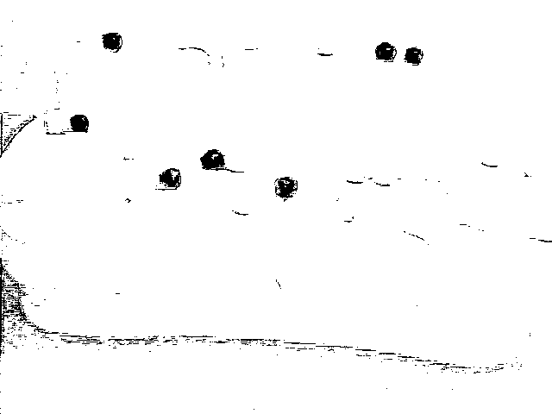

Figure 2

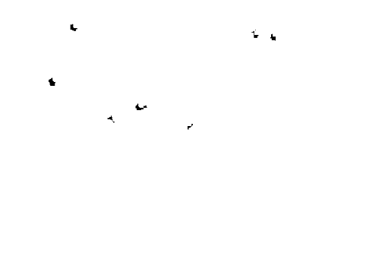Figure 3

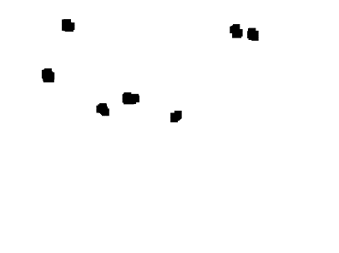

Figure 4

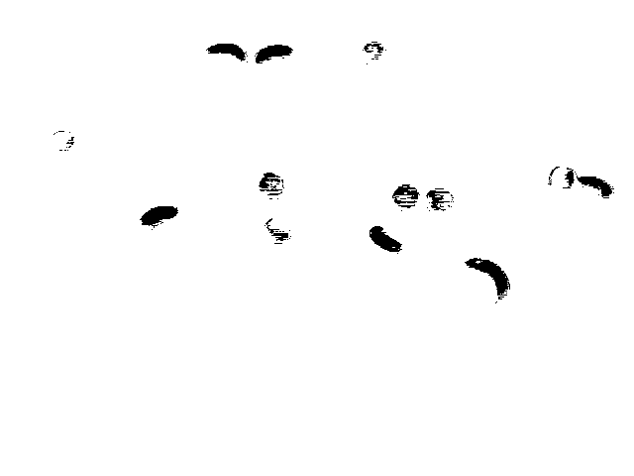Figure 5



Figure 6



Figure 7

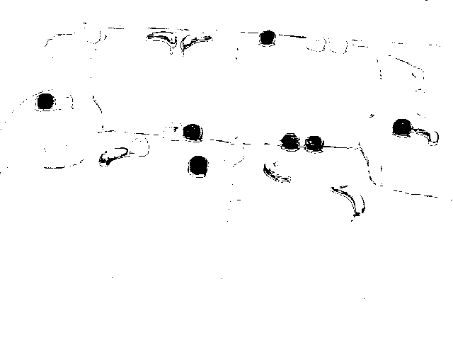

Figure 8

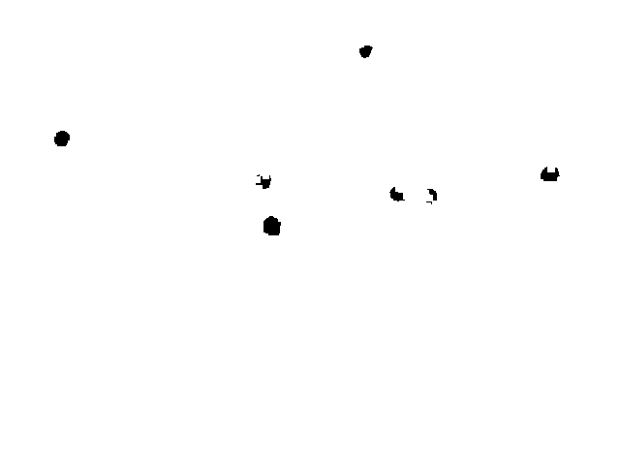

Figure 9

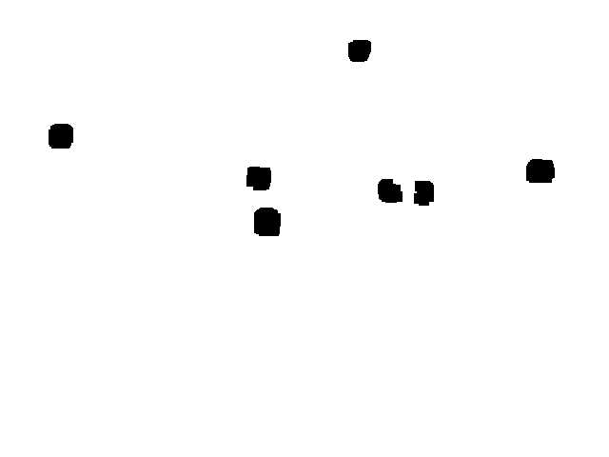

Figure 10

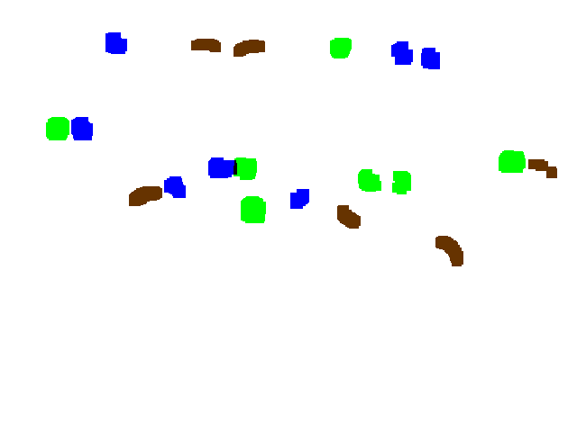

Figure 11

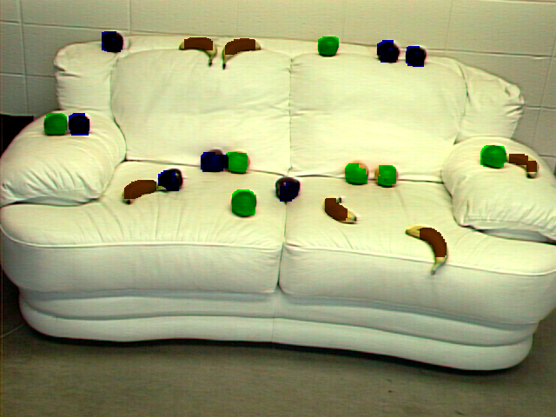

Figure 12